Setting up your home page and making it publicly available over internet by uploading it to GitHub Pages is your task for today.
Steps:
- Create your homepage that looks like one in the picture below. Home page will have list of links for your everyday assignments. Just keep placeholder text in the list item for today. You will update this list with links for your every other assignment so that I can easily get access to all your assignments directly from the home page.
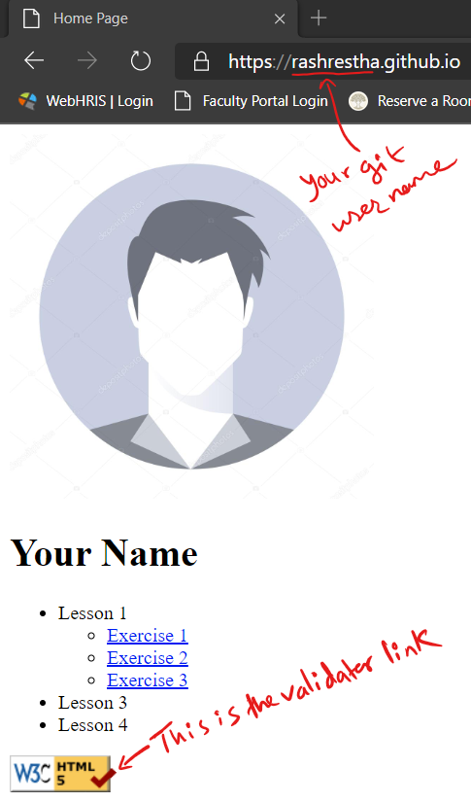

- Below the list of assignment add HTML table for our course overview table from the syllabus.
- We will be using GitHub Pages to host our site. For this first and foremost you need to have a GitHub account. After that you should be able to easily follow guide at the GitHub Pages website.
  - If you are not already familiar with git and git commands, you can also use GUI tool GitHub Desktop. Link to GitHub Desktop.
- At the bottom of your home page you need to add link to HTML5 validator you can copy and paste the following code:
<p>
<a href="https://validator.w3.org/check/referer">
<img src="html5_validator.png" alt="Validate" />
</a>
</p>

- Once the site is hosted and publicly available, you can click on the validator link to validate your web page.
  - Note: validator link will not work when you try locally in your machine. Why??
- Once you are done you just need to copy and paste the GitHub pages URL in Sakai assignment.
- Apart from the URL, also write a short note on your lab experience including following points:
  - Is the lab completed? Or what percent of the lab is completed?
  - Time spent
  - Major issues, new things learned?
  - Any further questions and concerns etc.
Note: Write your experience directly on Sakai, do not create a separate text or word file.
- You also have reading assignments (links to W3Schools), last slide of the lecture.

